________________ School District

January 2008

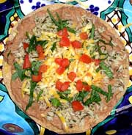
Kids Can Cook!

Tasty Tostada
This simple and quick dish uses foods from every food group. Serve with lowfat or nonfat milk and fruit for dessert.

Whole wheat tortilla
Canned beans, such as pinto, refried or black beans
Fresh vegetables, such as chopped lettuce and tomato
Grated cheese, such as 2% reduced-fat cheddar
Salsa

Lightly toast the tortilla under
the broiler on both sides.
Put the beans in a bowl and
microwave until warm.
Let children spoon beans onto
tortilla then top with veggies.
Sprinkle with cheese and top
with salsa, if desired.

Growing Healthy Children
Health at Any Size
at Any Size!


Too often people focus on weight in January, making resolutions to lose weight. It’s important, especially with children, to keep in mind that there is no “ideal” body size. Rather, encourage kids to accept that healthy people come in all different sizes. The goal is to be healthy. Lifestyle (how we live) is a better measure than weight when it comes to good health. Being physically active 60 minutes or more each day and eating healthful foods in moderate portions will help normalize many health indicators, such as blood pressure, blood sugar and blood cholesterol.

Good health is a state of physical, mental, social and spiritual well-being—not a number on a scale. Help your children feel good about their bodies. Be a role model and say positive things about your own body. Let your children know that health is more important than body size or shape.

Signs of low self-esteem can include poor eating habits and reluctance to be physically active. Boosting self-image will give your child more confidence. This in turn supports children taking care of themselves. Aim to say at least three positive things to your child each day.
Loving Your Family. . .

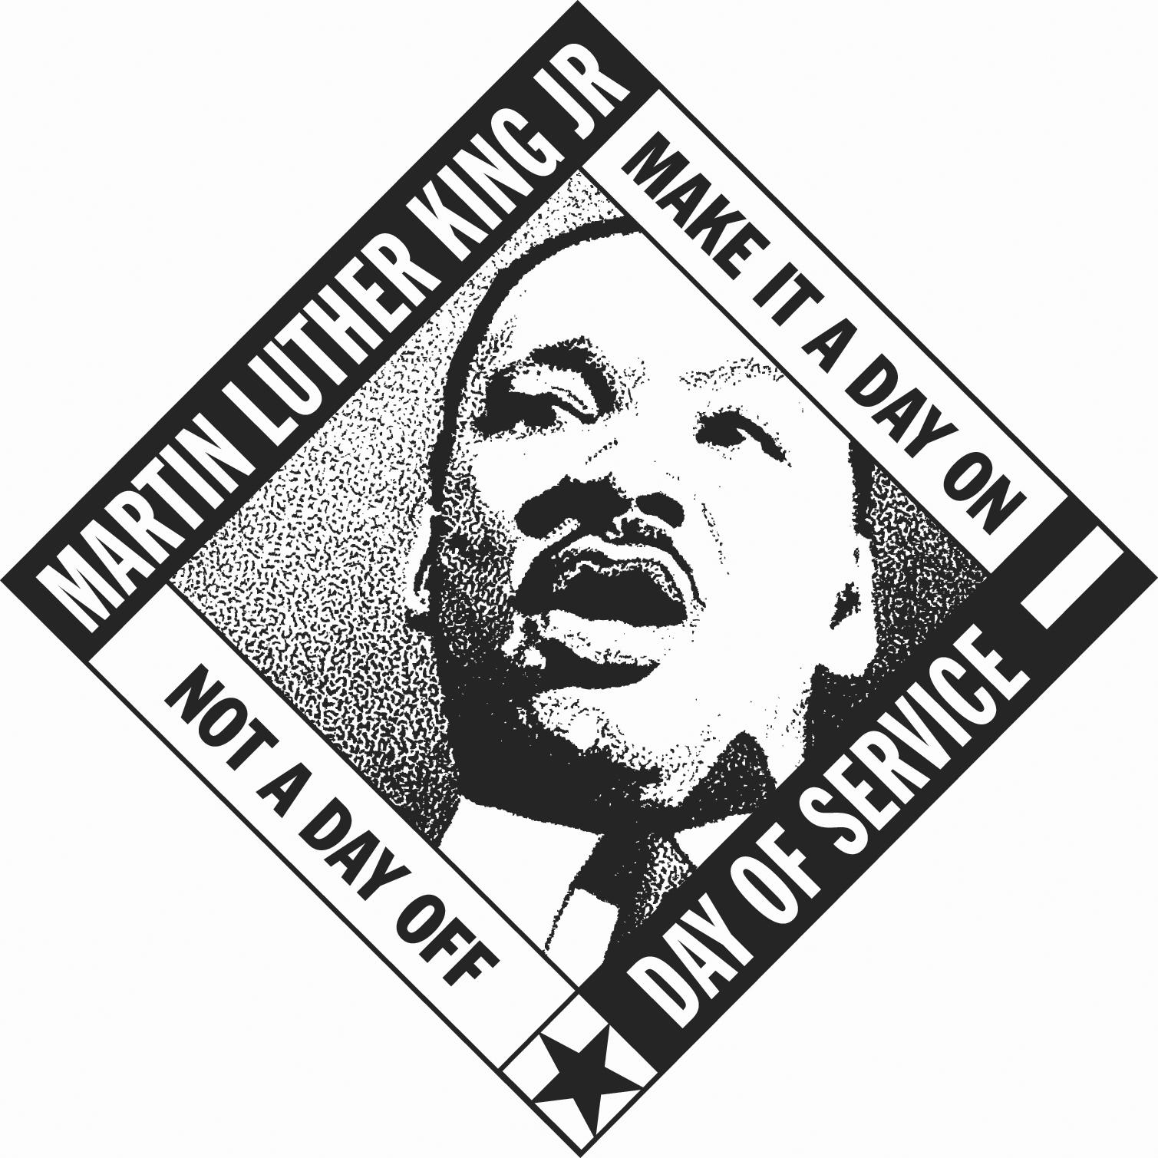
Martin Luther King, Jr. Day
January 21, 2008
Day of Service

Consider celebrating this year by doing an
MLK Day Service Project. Find out more
at: www.mlkday.gov




