Safeguard
Your
Child’s
Health
Growing Healthy Students

_________________________ School District

Berry Good
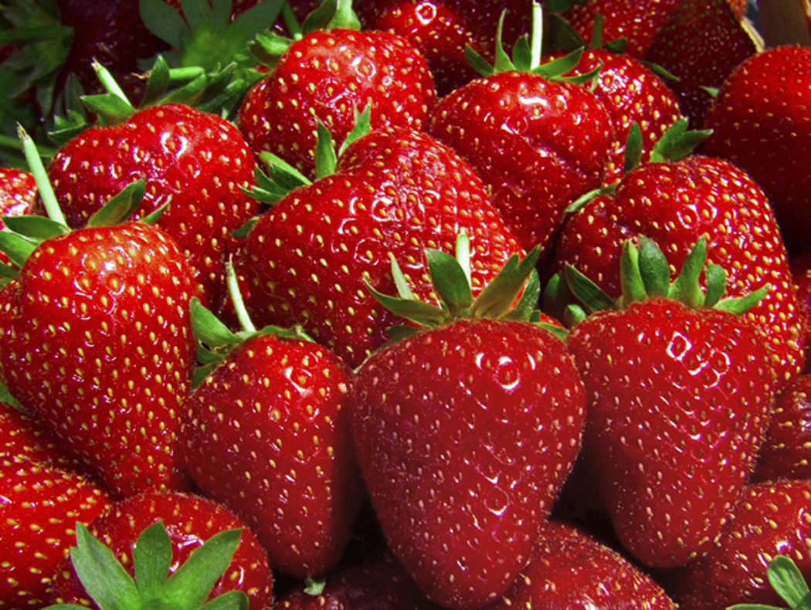
for You
Yumm…. berries are delicious AND, lucky for us, nutritious. Strawberries, blueberries, black-berries, cranberries and more, all pack a punch of flavor. These fruits are rich in vitamin C and fiber. They’re also brimming with power-ful antioxidants which protect cells and some may even boost brain power.

Berries are in season during spring and summer. Eat them as often as you can, adding them to cereal, tossed salads, yogurt or other fruit.



Wash berries right before eating. Gently rub them under briskly running water to wash away bacteria as well as dirt. Keep refrigerated.

Loving Your Family
If berries seem a bit expensive, consider a family outing to pick them. Look for U-pick farms in your area. Children love to pick berries and enjoy seeing how their food grows. Picking them yourself not only saves money but seems to make them taste even better. Find U-pick farms by contacting your Washing-ton State University County Extension office or farmer’s market.
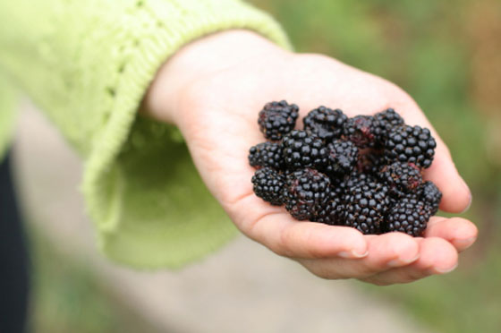
Munch on Lunch in Summer
Did you know your children can get “school” lunch even during the summer?! Ask your child’s school to see if there is a Summer Feeding Program in your area. During the summer keep your kitchen stocked with easy-to-make, nutritious foods that elementary-aged children can fix for themselves for lunch.

June
2010

Kids in the Kitchen
Patriotic Parfaits
Serve this refreshingly cool treat for those red-white-and-blue holidays. Makes 1.

1/2 cup vanilla yogurt
1/2 cup each: red berries, blueberries
1 tablespoon crunchy cereal

1. In a clear glass or plastic cup, layer half the red berries, half of the yogurt, then half of the blueberries.
2. Repeat.
3. Top with crunchy cereal such as a low-fat granola.

Berry-good options: For red berries, try sliced strawberries or raspberries. Berries can be fresh or frozen.

