____________ School District

March 2006

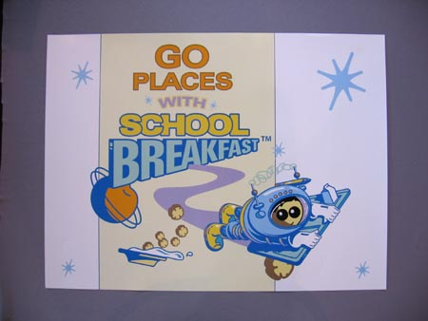


Kids Can Cook!
Caterpillar Roll-Ups
These are as much fun to make as they are to eat!

Spinach leaves
Orange segments
Shredded coconut

Lay spinach leaves out flat on
clean cutting board.
Place one orange segment
lengthwise on each spinach leaf.
Sprinkle lightly with coconut.
Fold and roll spinach leaves over
orange segment to form a log shape.
5. Use toothpick to hold it together

Lucky Leprechaun says to “Eat green” to get the vitamin A and C you need to be healthy!

Eat Breakfast at School


Go places with school breakfast!
March 6 – 10 is National School Breakfast week. Breakfast helps students learn and do better on school work and tests. Make sure your children have breakfast every day.

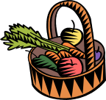
March is National Nutrition Month
Eat fruits or vegetables with every meal!
A healthy breakfast has a low-sugar food from 3 or more food groups. For instance, try a whole grain cereal, low fat milk and fruit. Fruit with breakfast makes sure the day starts with vitamin C. Go easy on juice though—no more than 1 cup per day. Chose whole fruit, it has more healthy fiber than juice. Kids need about 1-1/2 to 2 cups of fruit a day.

March is National Nutrition Month
Eat fruits or vegetables with every meal!

Now It’s Your Turn!

Eat a healthy breakfast! Draw a line from the clue to its picture.

1. I’m round, juicy, sweet and full of vitamin C.

2. My calcium builds bones and I’m cool and white.

3. My carbohydrates give you energy to “Go” on.

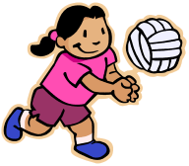
Families on the Move. . .

Looking for things to do inside when the weather’s too cold or wet to play outside? Try a game of balloon volleyball. Tie a string between two chairs and volley the balloon back and forth. Or use some other small, lightweight ball such as a Nerf ball or stress ball. Have a group of kids? Ask an adult to move the cars out of the garage and set up a larger balloon volleyball court.



Looking for things to do inside when the weather’s too cold or wet to play outside? Try a game of balloon volleyball. Tie a string between two chairs and volley the balloon back and forth. Have a group of kids? Ask an adult to move the cars out of the garage and set up a larger balloon volleyball court. Or use some other small, lightweight ball such as a Nerf ball or stress ball.


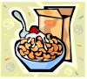
Information provided by Washington State University Extension’s Food $ense. This material funded by OSPI Child Nutrition Services. Extension programs are available to all without discrimination. Evidence of noncompliance may be reported through your local Extension Office.

