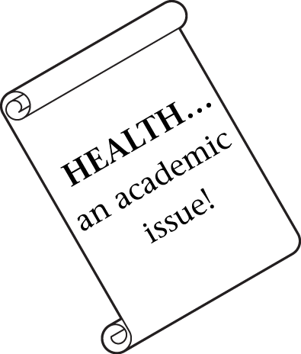
Building Healthy Students

_________________________ School District November 2008

Buy Foods for Learning


Buy Foods for Learning
Make your food dollars really count! Buy foods that are full of the nutrients kids need to think, learn and grow. Whole foods have these nutrients. A good place to find whole foods is around the perimeter of your grocery store. Typically you’ll find fruits, veggies, low- or non-fat dairy foods, lean meats and whole grain breads around the outer aisles of a market.
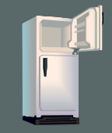

Stock up on these healthy foods when they’re on sale and freeze them. Milk and cheese freeze well. Chop veggies, put in boiling water for a few minutes, cool and then freeze. Fruits can be chopped, frozen on a cookie sheet then bagged.



Loving Your Family
As the weather gets colder, it may take extra effort to continue being physically active. So plan ahead. Make physical activity a regular part of your family's daily or weekly schedule and write it on a family activity calendar. Check out your local Parks & Recreation activity classes such as aerobics or dance. Choose something you and the kids can do together. www.wecan.org

Remember those who served in America’s military on Veterans Day, November 11. Look for events in your area at: http://www.dva.wa.gov/public_events.html

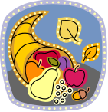

Kids Can Cook!

Make this after-school snack for your friends before heading out to play.

Low-fat graham crackers
Slices of your favorite fruits
(apples, bananas, oranges, pears)
Vanilla yogurt
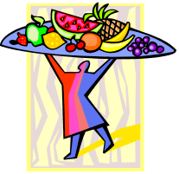

- Spoon some vanilla yogurt into a small bowl. Place in center of a plate.
- Wash and slice fruits.
- Break graham crackers into 4 pieces along the line pressed into them to make sticks.
- Arrange graham cracker sticks and fruits on plate. Dip into yogurt.

