________________ School District

October 2004

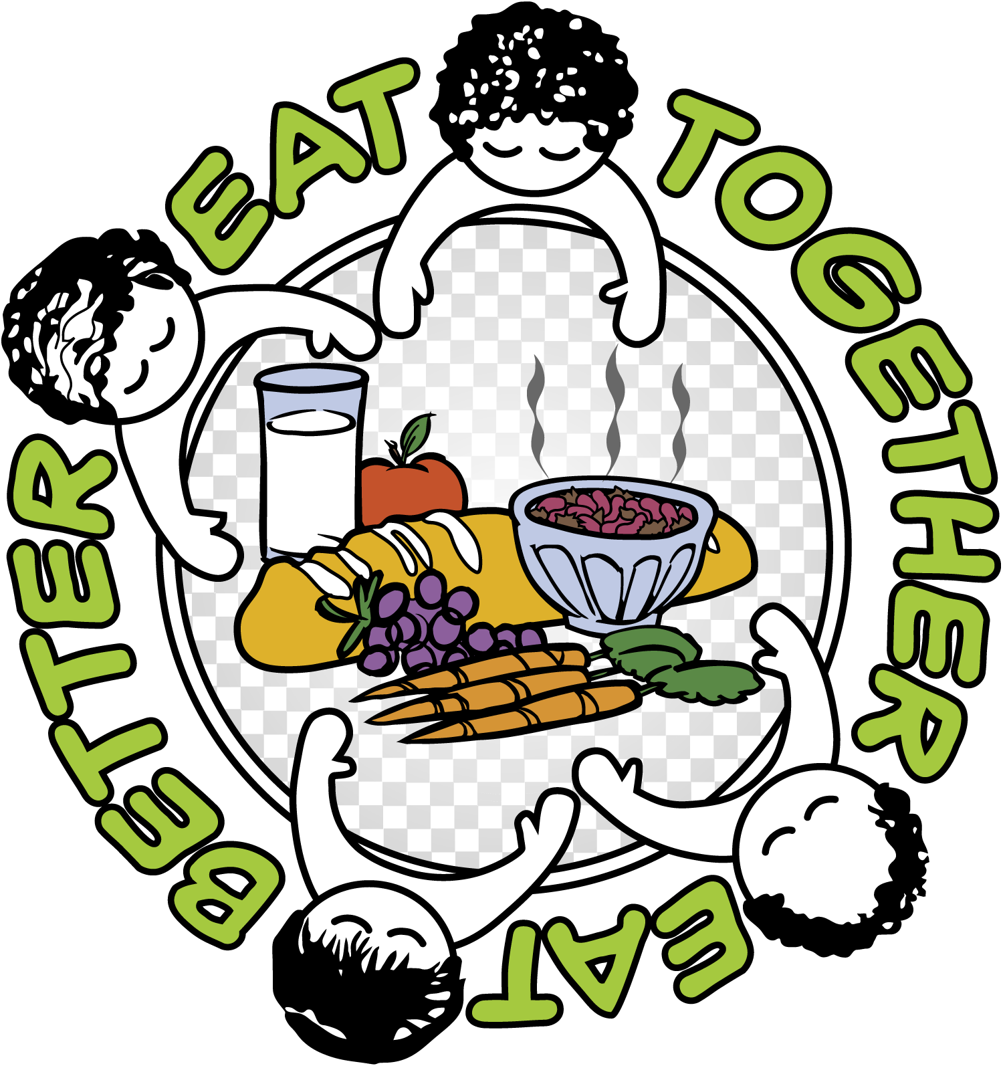

National Eat Better, Eat Together Month

Kids Can Cook!

Harvest Apples 

2 apples
4 teaspoons honey OR brown sugar
Cinnamon
- Have an adult turn on the oven to 350° F and cut apples in half lengthwise.
- Set apples, cut side up in a small baking dish that has about one-half inch of water in the bottom.
- Drizzle honey (or sprinkle brown sugar) on top of apples.
- Sprinkle cinnamon on top of apple.
- Cover with lid or foil and bake 25-35 minutes.
- Have an adult check the apples—they are done when a fork will easily poke into them. Have adult take out of oven.
- Let cool for 10 minutes. Eat warm. Makes 2-4 servings.

When Adults, Children and Teenagers Eat Together...
- Children do better in school.
- Children have fewer behavior problems.
- Teenagers are less apt to use alcohol or drugs.
- Children and teenagers say they like having time to talk to the adults in their lives.
- Communication between children and adults improves.
- Children understand their family's values and traditions.
- Family traditions are created around food and meals.
- Meals are more nutritious and healthful.
- Food dollars are better utilized with larger sized purchases.
- Time is better utilized because the family only cooks one meal.
National School Lunch Week October 11-15

Be smart, grow strong—
Eat lunch at school!


Now It’s Your Turn!

Make placemats for each person in your family. Use clean scrap paper or construction paper. Decorate placemat in each person’s favorite color, add pictures of their favorite foods, and put his or her name on the placemat.



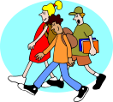
Families on the Move. . .

National Walk to School week is October 4-8, 2004. Find a safe route to walk with others to school. Walking together gives you time to talk with friends, and makes your heart strong. Just for Fun: See how many birds you can count while walking to school!

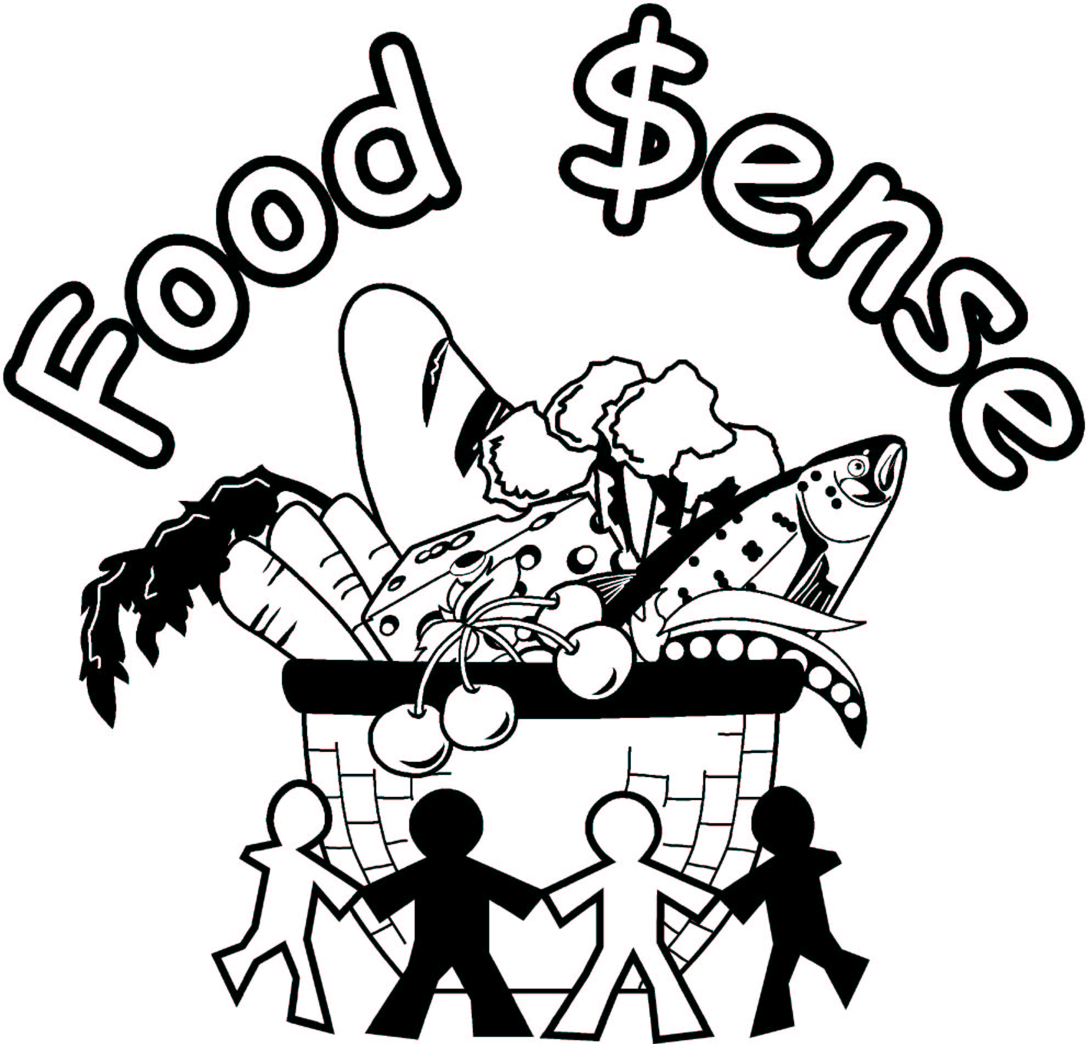
Information provided by Washington State University Extension’s Food $ense. This material funded in part by USDA-Food Stamp Program, state and local government agencies.
Basic Food assistance helps people with low incomes. To find out more, contact your local DSHS-Community Service office.
Extension programs are available to all without discrimination. Evidence of noncompliance may be reported through your local Extension Office.



